**BOTNAME – Readme**

**Bot Overview**

This bot performs the following:

* Reads the text from a file and returns a variable with all the content.

**Pre-Requisites**

* Automation Anywhere Enterprise v10 sp2

**Installation**

* Download the bot from Bot Store.
* Unzip the zip archive.
* For **first time users**, create “**Bot Store**” folder under **<AA Directory>/My Tasks** *(on your local disk)*.
* Copy folder “**Read Content-AA**” to above created Bot Store folder inside **<AA Directory>/My Task** in Automation Anywhere folder on your local disk.
* Move the “**[Utilities] ReadContentFromFile.mbot**” file from *(unzipped)* **R[1]ead Content-AA/My Metabots** to **<AA Directory>/My Metabots** folder in Automation Anywhere directory on your local disk.

**Create the following folder structure of the content in the AA Dir:**

<AA Directory>

* + My Tasks
    - Bot Store
      * Read Content-AA (Folder)
        + My Task

[Read from File] Stub.atmx

* + - * + Error Folder

Logs (Folder)

Error Logs Month-Day-Year.txt

Snapshots (Folder)

Error Snap Month-Day-Year.png

* + My Metabot
    - WordMetabot.mbot

**How to Use the Bot:**

**Use the following information to configure your bot:**

|  |  |  |  |
| --- | --- | --- | --- |
| **Parameter Name** | **Type** | **Direction** | **Additional Info** |
| vFilePath | String | Input | Provide file path.  E.g. C:\User\Desktop\TestBot.txt |
| vResponse | String | Output | Returns a string containing all the content from a file |
| vErrorFolder | String | Input | This is error folder inside bot folder which contains Logs and Snapshots folder (Already defined, no need to add value unless want to change location of file). |
| vLogFolder | String | Input | This folder contains Log file in case of error (Already defined, no need to add value unless want to change location of file). |
| vSnapshotFolder | String | Input | This folder contains Screenshot in case of error (Already defined, no need to add value unless want to change location of file). |

**Error Handling**

* Each Bot folder contains the below hierarchy.
  + Error Folder
    - Logs
      * Error Logs Month-Day-Year.txt: In case of any error, this file logs error message along with time stamp
    - Snapshots
      * Error Snap Month-Day-Year.png: In case of any error, this file captures screenshot of error.
* Task Status of bot is set to failed in case of error.

**Bot Deployment**

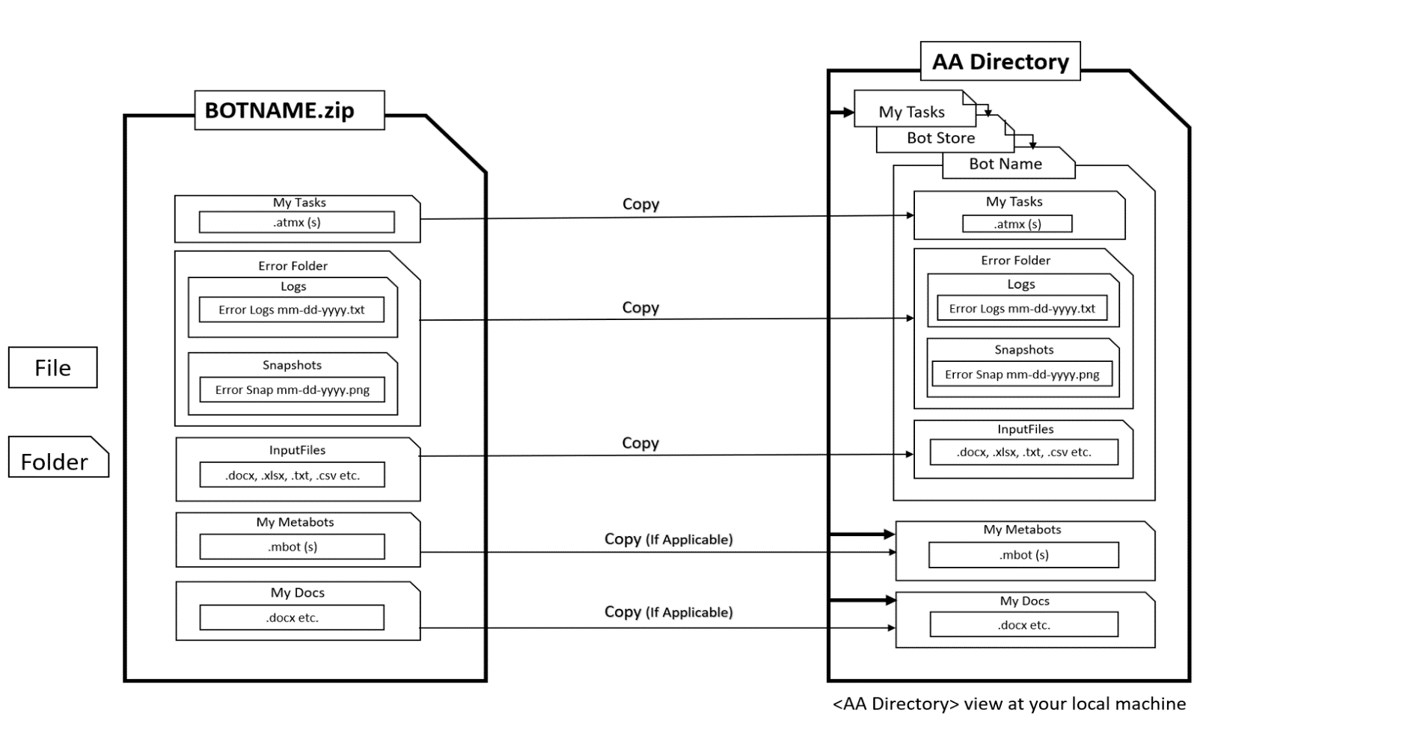

1.